TOWNSEND BOARD OF HEALTH
272 Main Street
Townsend, MA 01469
www.townsendma.gov
978-597-1713

Massachusetts Waste Ban Regulations 310 CMR 19.017
Mattresses/Box springs were added to the list of materials banned from disposal or transport for disposal in Massachusetts, which will have an effective date of November 1, 2022.
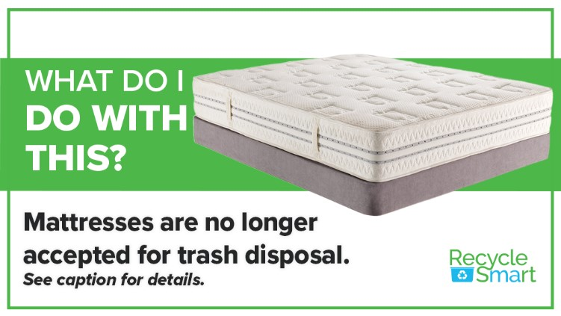
WHAT CAN YOU DO?
Starting Nov 1st CONTACT TOUGH STUFF RECYCLING AT 1-800-273-4137
(Soon to be available online also)

TO COME PICK UP YOUR MATTRESS/BOX SPRING CURBSIDE FOR $55.00 BUT...
You have to purchase a mattress bag available at the
Town Hall Board of Health Office 1st Floor, 272 Main Street or
the Recycling Center for $5.00 each

Check out the information on the back of this sheet for how to recycle from home!

Want to save a few dollars? You can still bring to the Recycling Center
but they must be acceptable and in a mattress bag (see definitions on back sheet).
$30/twin $40/full/double and $50king/queen

Reuse option: Post on Groton Free Stuff (trashnothing.com) or bring to www.householdgoods.orgin Acton MA, if in great condition

This does not include any mattress pad, mattress topper and Mattresses/Box Springs in futons and sofa beds.

An acceptable or “conforming unit” is defined as:

- Free of human bodily fluids or contamination
- Free of bed bugs or other insects/vermin
- Not heavily soiled, mildewed, or subject to damage as a result of being in the rain or snow for any given amount of time

Any unit that does not meet the above definitions are considered by Massachusetts Law as solid waste and will not be picked up by Tough Stuff Recycling Staff or Townsend Recycling Center Staff for recycling

WHAT TO DO IF YOUR MATTRESS OR BOX SPRING IS NOT RECYCABLE?

If you have any questions on what to do with a “non-conforming” or unacceptable mattress/box spring defined above, please reach out to
G.W. Shaw & Son at 800-649-7419 for pick-up.
Prices are $50/twin, $60/double/full and $70/king/queen

All Mattresses/Box Springs set out for curbside pickup use the following manner:

- Mattress/Box spring must be placed in a mattress bag to protect it from the elements and ensure safe handling for our curbside team. We ask that you tape the opening to secure the unit inside.

You can purchase a mattress bag available at the Town Hall
Board of Health Office 1st Floor, 272 Main Street, or
the Recycling Center for $5.00.

- Placed at the curbside – NOT at the front door or on private property – Mattresses/Box Springs must be visible for pickup service

Important - Mattresses/Box Springs that do not meet the standards noted above will be photographed or tagged with a reason the unit was not picked up

FUNDED BY A GRANT WITH MassDEP

