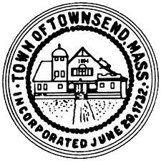
Townsend Historic District Commission
Meeting Minutes of March 23, 2022

The meeting was called to order at 4:35pm.
Roll call was conducted, in attendance were, Eino Kauppi, Clare Kauppi, Maryjane Churchville, Ken Diranian, Alisa Struthers.

A motion to approve the meeting minutes of March 2,2022 as amended and approve the chairman to sign and file was made by Maryjane Churchville, 2nd by Eino Kauppi
Votes were unanimous to approve
A motion to approve the draft letter to realtors was made by Clare Kauppi,2nd Maryjane Churchville.
Votes were unanimous to continue the matter to the next meeting to allow for corrections in address format.
Discussion was held updating the commission on newly sold properties in West Townsend.
The subject of over signage at the Brick Store was discussed. It was stated a letter to the owner needs to be sent requiring the signs be removed as it is no longer an operating business.
A motion to adjourn was made by Ken Diranian,2nd by Clare Kauppi to adjourn at 6:25pm
Votes were unanimous to adjourn

