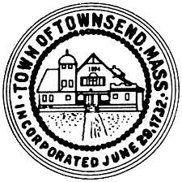
TOWNSEND HISTORIC DISTRICT COMMISSION
MEETING AGENDA
May 11, 2022 4:00pm
Great Hall
Townsend Town Hall

- Call the meeting to order conduct roll call

- 4:30 pm Public Hearing to review an application from Mei Huang for a Certificate of Appropriateness for exterior work to be done at 432 Main Street Townsend Ma.
votes may be taken

- A review of non-approved exterior work at 432 Main Street Townsend MA. will also be reviewed with Mei Huang. - votes may be taken

- Adjourn

