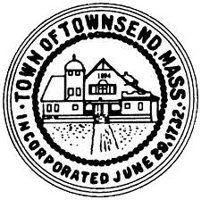
Townsend Historic District Commission
Meeting Agenda
March 23, 2022
4pm
Meeting room 2
- Call the meeting to order, roll call
- Approve meeting minutes of March 2, 2022 votes may be taken.
- Review draft letter to Realtors. Votes may be taken
- Enter work session
- Adjournment

