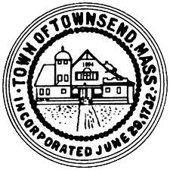
Townsend Historic District Commission
Meeting Agenda
July 6, 2022 4:00 pm
Great Hall at Townsend Town Hall

- Call the meeting to order, conduct roll call.

- Approve meeting minutes of June 8, 2022
Votes may be taken

- Conduct the Public Hearing for an application submitted by the Townsend Historical Society for a Certificate of Appropriateness for the installation of a fence at 80 Main Street.
Votes may be taken.

- Adjournment

