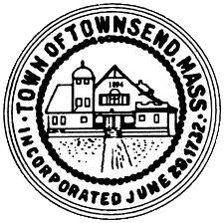
Townsend Historic District Commission
Meeting Agenda
April 6, 2022
4pm Meeting room 2
Townsend Town Hall
- Call the meeting to order, roll call
- Approve meeting minutes of March 23, 2022 votes may be taken.
- Review draft letter to realtors. Votes may be taken
- Review Historic Districts resident postcard
- Set a date for public hearing 432 Main Street
- Work Session
- Adjourn

