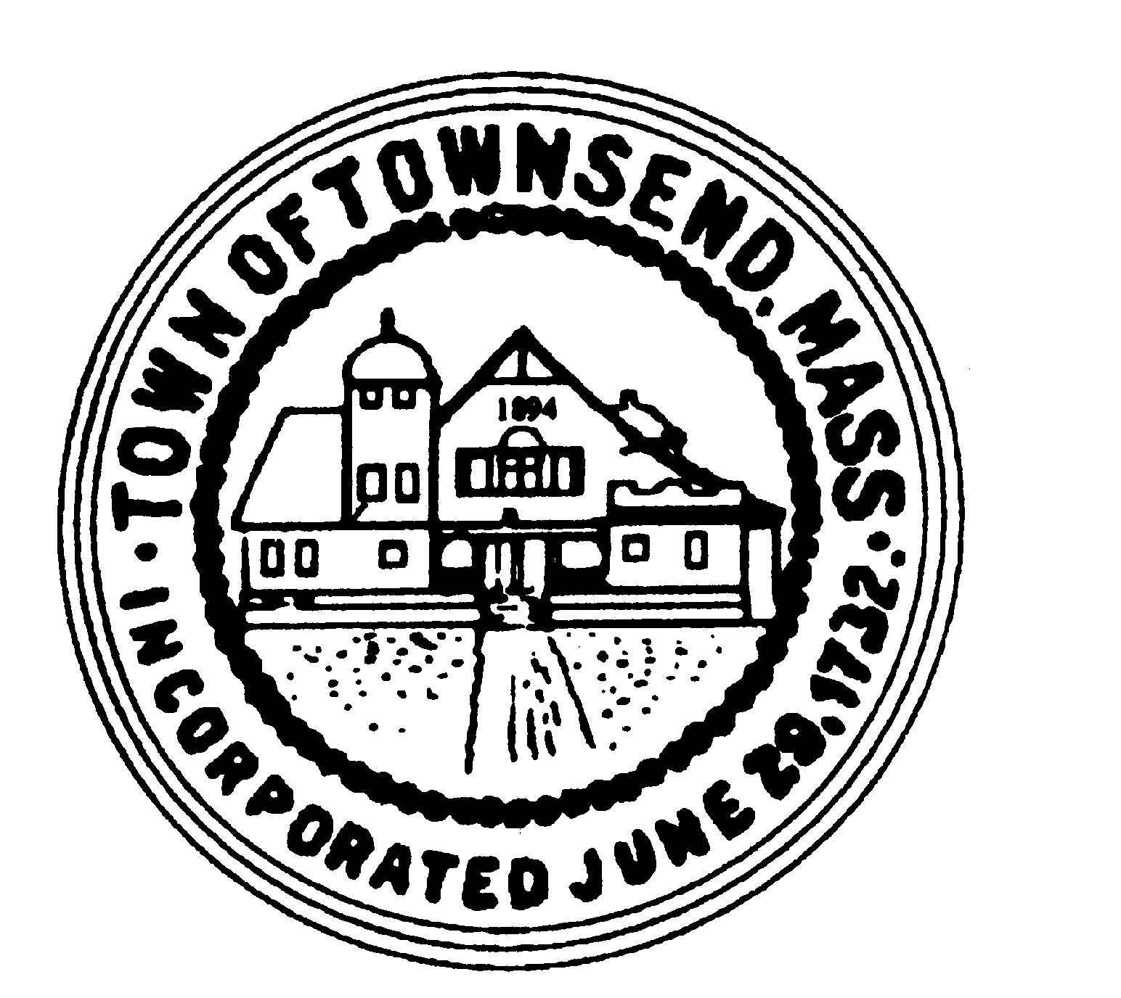
TOWNSEND BOARD OF HEALTH
272 Main Street
Townsend, Massachusetts 01469

Christopher Nocella, Chairman James Le’Cuyer, Vice-Chairman Gavin Byars, Clerk
Office (978) 597-1713 Fax (978) 597-8135

April 12, 2021 at 10:00 a.m., EST
Board of Health members and staff will meet in Meeting Room 2 at Memorial Hall

The Board of Health meeting is also being held virtually in accordance with the Governor’s Executive Order Suspending Certain Provisions of the Open Meeting Law, MGL c. 30A. s.20. Interested individuals can listen in and participate by phone by dialing the phone number below and using the provided access code. Telephone Number: 1-717-275-8940 Access Code: 6602188

PRELIMINARIES

  - Roll Call
  - Additions or Deletions not anticipated 48 hours in advance

APPOINTMENT/HEARINGS

  - CO-VID Update
  - Lot 5 Campbell Farm Lane – New Construction
  - Other permits for review

WORK SESSION
  - Curbside Trash and Recycling program update
  - Invoices for approval
  - Minutes of February and March 2021
  - Recycling Center updates- new employee, comcast, etc.
  - Future Agenda Items
    - Job Description Review for Recycling Center Attendants
    - 96 Fitchburg Road – Manure Management Plan Update
    - Timberland Farm – Site Plan Review

ADJOURNMENT

