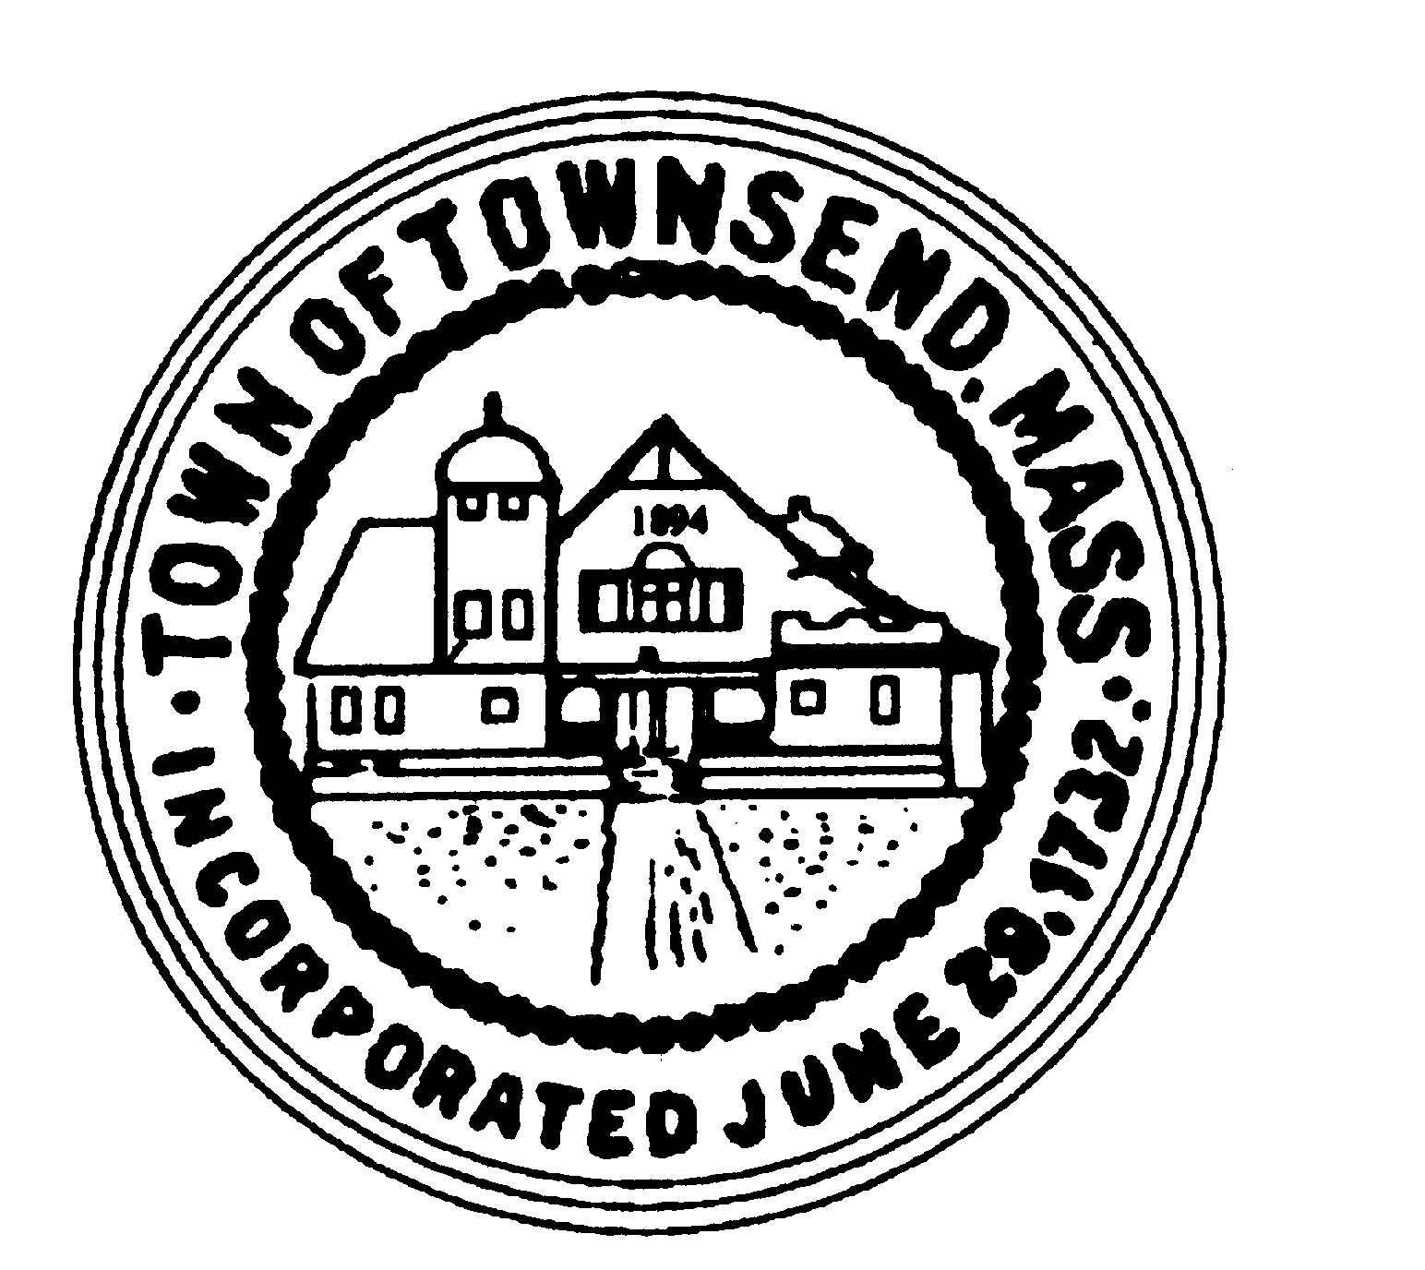
TOWNSEND BOARD OF HEALTH
272 Main Street
Townsend, Massachusetts 01469

Christopher Nocella, Vice-Chairman James Le’Cuyer, Chairman Gavin Byars, Clerk
Office (978) 597-1713 Fax (978) 597-8135

WEDNESDAY, September 6, 2023, at 7:00pm, EST
Board of Health members and staff will meet in the
Meeting Room 2 Memorial Hall 272 Main Street

This meeting of the Board of Health will be held in-person at the location provided on this notice. Members of the public are welcome to attend this in-person meeting. Please note that, while an option for remote attendance and/or participation is being provided as a courtesy to the public, the meeting will not be suspended or terminated if technological problems interrupt the virtual broadcast, unless otherwise required by law. Members of the public with particular interest in any specific item on this agenda should make plans for in-person versus virtual attendance accordingly. Dial-in number: 605-313-4278 Access code: 5843884 PIN Online meeting ID: cwalter17

PRELIMINARIES
  - Roll Call
  - Additions or Deletions not anticipated 48 hours in advance.

APPOINTMENT/HEARINGS
  - Re-Appointment of Officers
  - Septic Permits for Review
  - Fall Meeting Schedule
  - Permit Fees increases.

WORK SESSION
  - Invoices
  - Recycling Center Update
  - Future Agenda Items
    - Executive Session G.W. Shaw & Son – November 2023
    - Tobacco Regulations Update: TBD
    - Next Meetings: TBD

ADJOURNMENT

Townsend Board of Health Meeting Minutes
September 6, 2023

- Roll Call: James Le’Cuyer, Gavin Byars present. 7:01p.m. meeting opens. Chris Nocella absent.

- Additions/Deletions: None

- Reappointment of Officers: Gavin Byars read the Board’s letter of conduct to the public specifically Veronica Kell and Cindy Bounty, and the town as a whole. Gavin discussed why he chose to be on the Board and his family life. Gavin asked Jim if he understood why the Board revoted the positions in the Board at that meeting. Jim and Gavin discussed their concerns going forward. Gavin asked if Jim was going to step down. Jim stated he would not. They discussed the politics of the past. They ended the discussion with different opinions on whether Jim should resign or not.

- Fall Meeting Schedule: On hold.

- Permit Fee Increases: 30% of the Nashoba towns have returned the survey.

- Next Meeting 1.9.3 Out of Order: Carla/Rick Gavin states this will be his last Board of Health meeting and he apologies to the Town. He asked for understanding. He has enjoyed working for the town and meeting the people. Gavin gives a special shout out to Rick Metcalf’s professionalism and always being prepared. He hopes the Town knows how much they should appreciate you.

- JL MOTION to adjourn the meeting. GB 2nd. Meeting adjourned at 7:43p.m.

